|  |  |  |  |  |  |  |
| --- | --- | --- | --- | --- | --- | --- |
| VILNIAUS KOLEGIJA  UNIVERSITY OF APPLIED SCIENCES  FACULTY OF ELECTRONICS AND INFORMATICS  Image result for viko logo | | |  | | | VILNIUS COLLEGE  Image result for viko logoFACULTY OF ELECTRONICS AND INFORMATICS |
|  | | |  | | |  |
| **SOFTWARE DEVELOPMENT MANAGEMENT** | | |  | | | **INTRODUCTION TO INFORMATICS** |
| PRACTICAL ASSIGNMENT  PROJECT WORK  6531BX028 PI18E | | |  | | | PRACTICAL ASSIGNMENT  SPOTIFY USER MANUAL  6531BX028 PI18E |
| STUDENT | DŽIUGAS PEČIULEVIČIUS  EDITA KOMAROVA | STUDENT | | DŽIUGAS PEČIULEVIČIUS |
| (SIGNATURE)  2/25/2021 | | |  | | | LECTURER |
| LECTURER | ASTA DANILEVIČIŪTĖ | (SIGNATURE)  10/17/2018 | | VIRGILIJUS KUKLIERIUS |
| (SIGNATURE)  2/25/2021 | | |  | | | 2018 |

2021

# PROJECT IDEA, GOAL AND SCOPE

## **Idea**

Project idea would be a clothing e-commerce shop.

## **Goal**

To create ecommerce website that provides clothes and quick & easy checkout for its clients

## **Scope**

* User should be able to login/register
* User should be allowed to order clothes.
* Browse products (clothes)
* Should be able to add products to cart and be able to pay for them
* Should be able to see order status.
* Should be able to checkout items with a credit card or PayPal.

## **Stakeholders**

* Project owner.
* Customers.
* Team members.
* Sellers.

## **Implementation location and time**

2021, Vilnius University of Applied Sciences, using virtual tools like MS Teams.

# PROJECT SCHEDULE AND BUDGET

## **Work breakdown structure (WBS)**

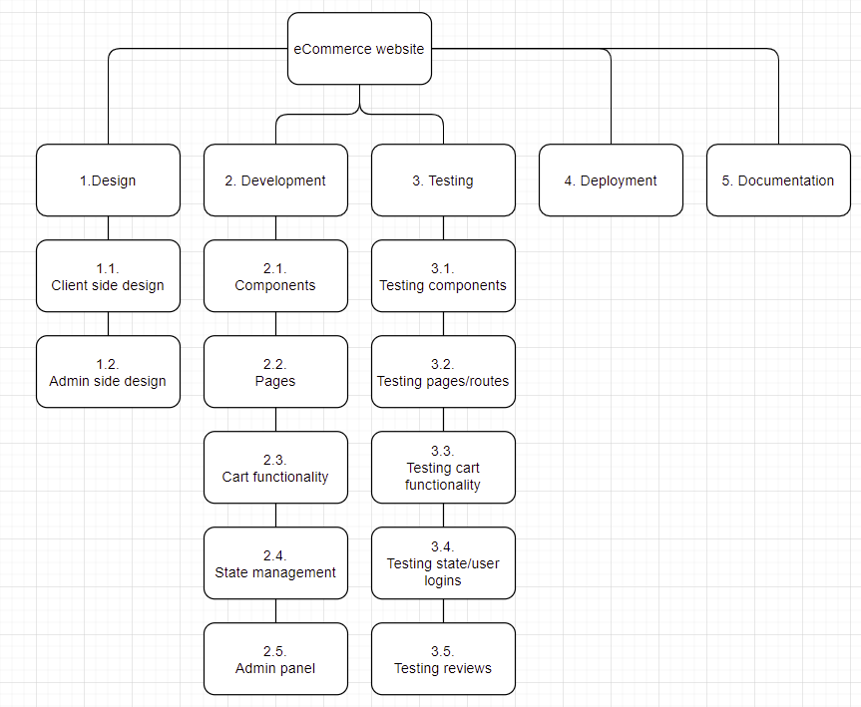

Figure 1 – WBS

## **Network Diagram**

## **Project tasks, their duration and dependencies**

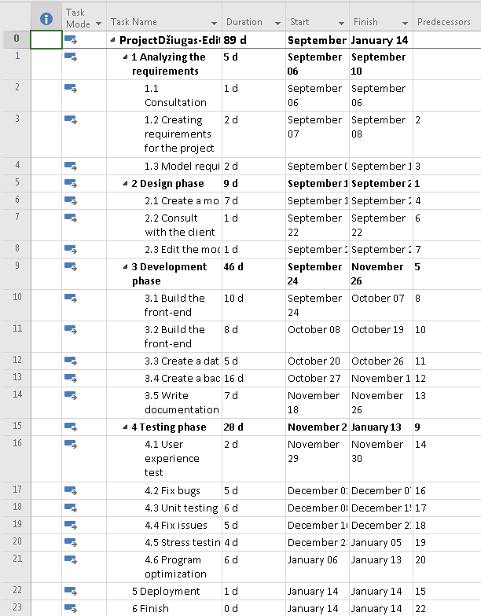

Figure 2 - Project tasks, their duration and dependencies

## **Material resources and their costs**

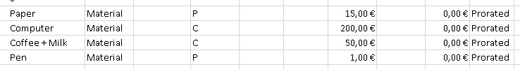

Figure 3 - Material resources

## **Human resources, payment rates and methods**

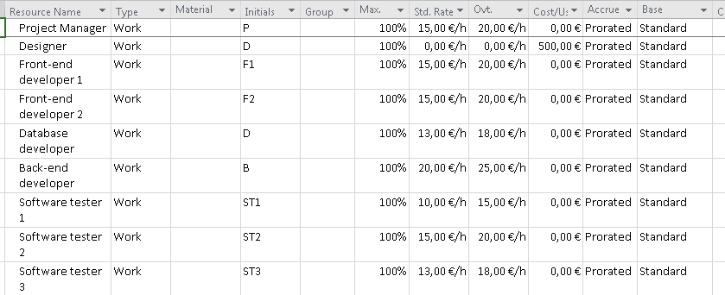

Figure 4 - Human resources

## **Fixed costs**

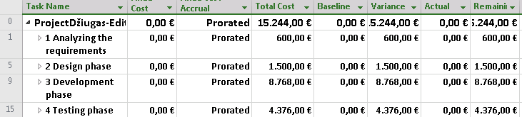

## **Resources assigned to project tasks**

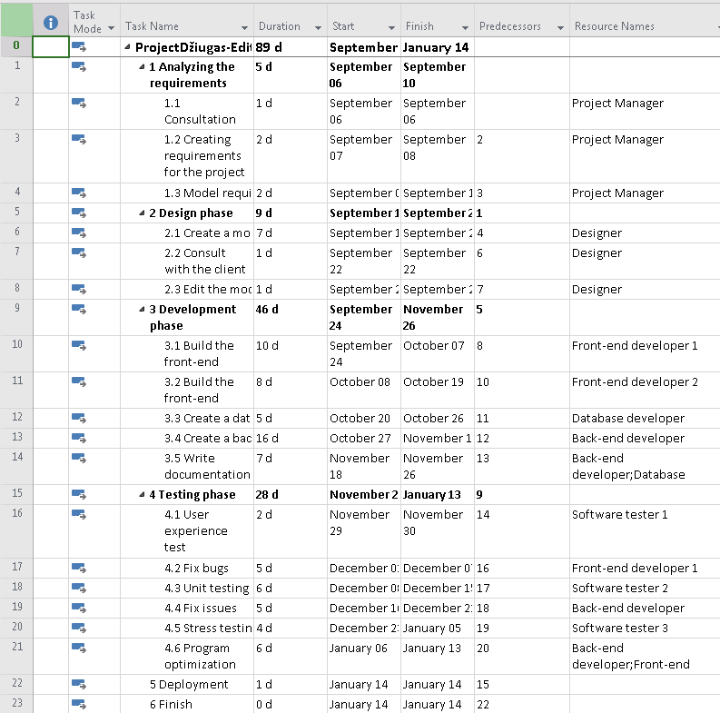

Figure 5 - project tasks with resources

## **Project schedule**

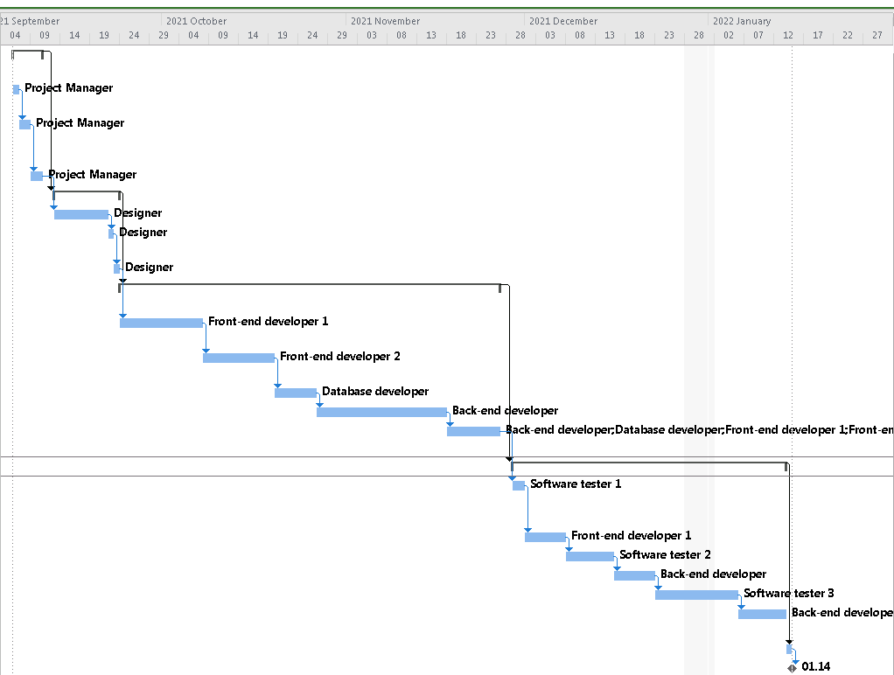

## **Project budget**

Project budget : 15,244€

**3. PROJECT FUNDING SOURCES.**

**3.1. Determine project funding sources.**

1. Loan - generally have higher rates of interest and are less flexible as payments need to be made for a pre-agreed amount and at a pre-agreed time. Loans can be repaid in stages or at the end of the loan period.
2. Business Angels- These are private investors who invest directly in a company in exchange for an equity stake and perhaps a place on the board.
3. Retained profits- Not all profits are distributed to shareholders: the company retains a proportion as reserves.

**3.2. Determine funding scope.**

1. Materials – materials such paper and pen will be used during the project’s timeline.
2. Human resources- Project managers, developers, testers will be paid based on the number of hours they spent working on the project.
3. Contractual workers – Designers who will be given a fixed price of the work they have done.
4. Licenses – licenses are needed for hosting database and website.

**4. PROJECT RISKS**

**4.1. Identify and analyse the project risks.**

|  |  |  |  |  |  |
| --- | --- | --- | --- | --- | --- |
| **No** | **Task name** | **Risk name** | Probability  **(P, 1-10)** | **Impact**  **(I, 1-10)** | **Score**  **(P*I)** |
| 1. | Cost risks | The project can get too expensive | 6 | 8 | 48 |
| 2. | Project purpose and need is not well-defined | This could lead to misunderstandings and that would impact total project duration. | 4 | 4 | 16 |
| 3. | Project schedule is not clearly defined or understood | This could impact project duration | 6 | 6 | 36 |

|  |  |  |  |  |  |
| --- | --- | --- | --- | --- | --- |
| 4. | No control over staff | This could lead to decrease in project quality and its duration | 4 | 10 | 40 |
| 5. | Unplanned work that has to be done. | This would increase the duration of the project | 5 | 10 | 50 |

|  |  |  |  |  |  |
| --- | --- | --- | --- | --- | --- |
| 6. | Lack of communication, causing lack of clarity and confusion | Lack of communication could reduce the quality of the project and its duration | 6 | 10 | 60 |
| 7. | Project conflicts not resolved in a timely manner. | Bugs that are not resolved on time could push back other deadlines that need to be met. | 7 | 10 | 70 |

|  |  |  |  |  |  |
| --- | --- | --- | --- | --- | --- |
| 8. | Theft of materials, intellectual property or equipment. | Theft of the property could cause company a lot of problems. This would not just push back the deadline itself, but would also need to cover new equipment expenses. | 2 | 10 | 20 |

**4.2. Determine risk reduction measures.**

1. To reduce the cost of material, we will go dumpster diving. To reduce the cost of the project, we should cheaper software.
2. We should do meetings and talk over every single little bit of things.
3. Then use proper software, define the project schedule properly that everyone understands.
4. Pay them higher salaries. Or fire them if they keep misbehaving.
5. Should have some time allocated between deadlines to finish those unexpected tasks.
6. Have some more time allocated for these kinds of conflicts.
7. Always be prepared for these kinds of thefts and have proper insurance.

**5. QUALITY MANAGEMENT**

**5.1. Determine project quality management.**

1. Consultation with the client – there will be consultation with the client to ensure that the client is satisfied with the requirement, design and result.
2. Meetings – in the meeting project manager will have a chance to inspect the work.
3. Testing – the project will be tested to ensure that website is going to work very smoothly.